**PROJECT REPORT**

On

***U-Share***

Submitted in partial fulfilment of the requirement for the

Course BEE (22CS026) of

**COMPUTER SCIENCE AND ENGINEERING**

# B.E. Batch-2022

**in**

**Jan -2025**



Submitted By

Under the Guidance of: -

|  |  |
| --- | --- |
| Rahul Singh Rajput  Project Supervisor | Name: Prabhat Kumar  Roll. No. 2210992048  Name: Piyush Jindal  Roll. No. 2210992045  Name: Prince  Roll. No. 2210992088  Name: Prakash Singh Roll. No. 2210992058  Name: Pratham Chaudhary  Roll. No: 2210992074 |

DEPARTMENT OF COMPUTER SCIENCE AND ENGINEERING

CHITKARA UNIVERSITY PUNJAB

# CERTIFICATE

This is to be certified that the project entitled “**U-Share**” has been submitted for the Bachelor of Computer Science Engineering at Chitkara University, Punjab during the academic semester July 2024- December 2024 is a bona fide piece of project work carried out by

* Prabhat Kumar (Roll No.: 2210992048)
* Piyush Jindal (Roll No.: 2210992045)
* Pratham Chaudhary (Roll No.: 2210992074)
* Prince (Roll No.: 2210992088)
* Prakash Singh (Roll No.: 2210992058)

This project is submitted towards the partial fulfilment for the award of the course **Integrated Project (CS 203)** under the guidance of “Rahul Singh Rajput” and supervision.

Sign. of Project Guide:

Rahul Singh Rajput

(Designation & Department)

## CANDIDATE’S DECLARATION

(16 Times New Roman)

We, **[Prabhat Kumar- 2210992048], [Piyush Jindal - 2210992045], [Prince - 2210992088]**, **[Prakash Singh - 2210992058]** and **[Pratham Chaudhary - 2210992074]** B.E.-2022 students of Chitkara University, Punjab, hereby declare that the Integrated Project Report entitled **“U-Share”** is our original work. The data provided in this study is authentic to the best of our knowledge. This report has not been submitted to any other Institute for the award of any other course.

|  |  |  |  |  |
| --- | --- | --- | --- | --- |
| **Signature:** | **Signature:** | **Signature:** | **Signature:** | **Signature:** |
| Prabhat Kumar | Piyush Jindal | Prince | Prakash Singh | Pratham Chaudhary |
| 2210992048 | 2210992045 | 2210992088 | 2210992058 | 2210992074 |

Place: ___________

Date: ___________

ACKNOWLEDGEMENT

It is our pleasure to be indebted to various people who directly or indirectly contributed to the development of this work and who influenced our thinking, behaviour and actions during the course of study.

We express our sincere gratitude to everyone for providing us the opportunity to undertake this Integrated Project as part of the curriculum.

We are thankful to **[Rahul Sir]** for the support, cooperation, and motivation provided throughout the training. Their constant inspiration, presence, and blessings have been invaluable.

Lastly, we would like to thank the Almighty, our parents for their moral support, and our friends, with whom we shared our day-to-day experiences and received suggestions that improved the quality of our work.

|  |  |  |  |  |
| --- | --- | --- | --- | --- |
| **Student 1** | **Student 2** | **Student 3** | **Student 4** | **Student 5** |
| Prabhat Kumar | Piyush Jindal | Prince | Prakash Singh | Pratham Chaudhary |
| 2210992048 | 2210992045 | 2210992088 | 2210992058 | 2210992074 |

# Table of Contents

|  |  |  |
| --- | --- | --- |
| **Sr. No.** | **Topics** | **Page No.** |
| 1 | Abstract | 6 |
| 2 | Introduction | 7 |
| 2.1 | Background | 7 |
| 2.2 | Problem Statement | 7 |
| 3 | Software and Hardware Requirement Specification | 8 |
| 3.1 | Methods | 8 |
| 3.2 | Programming/Working Environment | 8 |
| 3.3 | Requirements to Run the Application | 9 |
| 4 | Database Analysing, Design and Implementation | 9 |
| 5 | Program’s Structure Analysing and GUI Constructing | 10 |
| 6 | Code-Implementation and Database Connections | 10-13 |
| 7 | System Testing | 13 |
| 8 | Limitations | 14 |
| 9 | Conclusion | 15 |
| 10 | Future Scope | 15 |
| 11 | Bibliography/References | 15 |

**1. Abstract:**

In the rapidly evolving landscape of university education, students often encounter challenges related to resource sharing, effective collaboration, and skill development, particularly in technical fields such as Computer Science. As educational institutions increasingly embrace digital platforms, the need for a centralized solution to facilitate peer interaction and knowledge exchange becomes paramount. *U-Share* is a web platform developed to address these issues by fostering a collaborative educational environment, enabling students to harness the power of collective learning.

This platform provides a comprehensive suite of features, including a centralized Shared Resource Repository, virtual Collaborative Workspaces for real-time project collaboration, and a dedicated Coding Challenge Arena that engages users through competitions and skill-building exercises. The design of *U-Share* emphasizes ease of use and accessibility, ensuring that students can efficiently upload, share, and discover study materials, lecture notes, and coding challenges tailored to various proficiency levels.

The primary components of *U-Share* are engineered to enhance peer-to-peer interaction and learning. Tools such as discussion forums, mentorship programs connecting experienced students with newcomers, and automated study group formation based on academic goals promote a sense of community and facilitate knowledge exchange. Additionally, an event calendar keeps users informed about academic events, workshops, and webinars, further enriching the educational experience.

Developed using a combination of Node.js for backend operations and React.js for frontend development, *U-Share* is structured to provide a seamless and engaging user experience. The platform’s cloud-based deployment ensures accessibility from any location and supports scalability to accommodate a growing user base. Furthermore, its emphasis on user feedback fosters continuous improvement, allowing the platform to adapt to the evolving needs of students.

Despite its potential, *U-Share* faces challenges such as the initial development costs, ongoing technical maintenance, and the need for robust data security measures. Ensuring active user engagement remains crucial for the platform's success, as it relies on user-generated content and participation for resource sharing and collaboration. Nevertheless, *U-Share* promises to be a sustainable and innovative solution for enhancing learning, building community, and equipping students with the necessary skills for their future careers.

1. **Introduction:**

* 1. **Background**

In the digital age, the educational landscape has evolved, yet many university students continue to face challenges in accessing shared resources and collaborating effectively. Traditional learning environments often lack the necessary tools for students to engage with one another and share knowledge.

*U-Share* aims to address these challenges by providing a centralized platform where students can access a wide range of study materials, collaborate on projects in real time, and participate in coding challenges. By focusing on peer interaction and community building, *U-Share* seeks to enhance the learning experience, empower students to share resources, and develop essential skills in a collaborative environment.

* 1. **Problem Statement**

University students often face significant obstacles in accessing shared resources, collaborating effectively, and developing essential coding skills.

Despite the availability of various educational tools, many students struggle to find relevant study materials, engage in productive group work, learning from seniors and participate in coding challenges that enhance their programming capabilities.

The lack of a centralized platform that integrates these functions results in fragmented learning experiences, where students are left to navigate multiple resources without effective support or collaboration.

*U-Share* addresses these challenges by providing a comprehensive web platform that serves as an educational hub. Key features such as a shared resource repository, collaborative workspaces, and a coding challenge arena will empower students to connect, share knowledge, and work together on projects, thereby fostering a sense of community and enhancing their overall learning experience. This initiative aims to bridge the gap between traditional learning methods and the collaborative opportunities offered by digital platforms, ultimately enriching the educational journey of university students.

1. **Software and Hardware Requirement Specification:** 
   1. **Methods** 
      1. **Frontend Development:** o **React.js:** Utilized for creating a dynamic and responsive user interface. o **HTML/CSS:** Employed for the structural layout and visual styling of the web application. o **JavaScript:** Used for adding interactivity and client-side logic.

* + 1. **Backend Development:**
       - **Node.js:** Chosen for its event-driven architecture to handle multiple requests efficiently. o **Express.js:** Implemented for routing and building RESTful APIs to facilitate communication between the client and server.
       - **MongoDB:** Selected as the database to store user data, shared resources, and coding challenges in a flexible, schema-less format.

* + 1. **Version Control and Collaboration:**
       - **Git:** Adopted for tracking changes and collaborating among team members.
       - **GitHub:** Used for hosting the project repository and facilitating code reviews.

* 1. **Programming Working Environment**

1. **Integrated Development Environment (IDE):**

o **Visual Studio Code:** Recommended for writing and managing code due to its extensive plugins and features that enhance productivity.

1. **Development Tools:**

o **Postman:** Used for testing API endpoints to ensure proper communication between frontend and backend components. o **Node Package Manager (NPM):** Employed for managing project dependencies and libraries.

1. **Browser:**

o **Google Chrome or Firefox:** Recommended for testing and debugging the application to ensure compatibility and performance.

**3.3 Requirements to Run the Application**

1. **System Requirements:**
   * **Processor:** Dual-core processor or higher. o **RAM:** Minimum of 8 GB to support development and application runtime. o **Storage:** At least 256 GB of free disk space for software installations and project files.

1. **Network Requirements:**
   * **Internet Connection:** Stable broadband connection for accessing cloud services, online resources, and collaboration tools.

1. **User Requirements:**
   * **User Devices:** Any device with a modern web browser (latest version of Chrome, Firefox, or Edge) for accessing the platform.
   * **Account Registration:** Users must register for an account to access collaborative features and resources on the platform.

1. **Role of U-Share in Database Analysis, Design, and Implementation**

*U-Share* plays a crucial role in:

1. **Data Management:** Facilitating efficient storage and retrieval of user profiles, shared resources, projects, and coding challenges.
2. **Schema Design:** Defining a flexible NoSQL schema in MongoDB to accommodate diverse data types and relationships.
3. **API Development:** Implementing RESTful APIs using Express.js for seamless interaction between the frontend and database.
4. **Performance Optimization:** Ensuring fast data access through indexing and optimized queries to enhance user experience.

By focusing on these areas, *U-Share* ensures a robust and scalable database solution for collaborative learning.

1. **Program Structure Analysis and GUI Construction**

**5.1 Program Structure Analysis**

*U-Share features a modular design:*

* **Frontend Module:** Built with React.js for user interface and interactivity**.**
* **Backend Module**: Developed using Node.js and Express.js for API management and database communication**.**
* **Database Module:** Utilizes MongoDB for storing user data and resources.

**5.2 GUI Construction**

*The GUI is designed for user-friendliness:*

* **Responsive Design:** Ensures compatibility across devices.
* **Intuitive Navigation:** Simplifies access to resources and features.
* **Interactive Elements:** Includes drag-and-drop uploads and real-time collaboration tools**.**

This structure and design promote an engaging learning experience in *U-Share*.

1. **Code-Implementation and database connections**

The backend uses Node.js to handle API requests for document management. MongoDB is accessed using the Mongoose library, which simplifies the interaction with the database.

Snapshots of code:

o

Database

o

Post.js

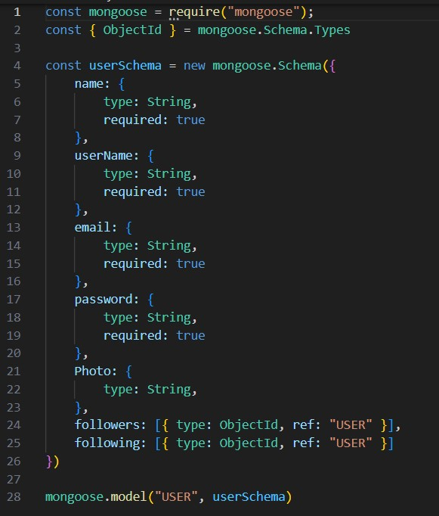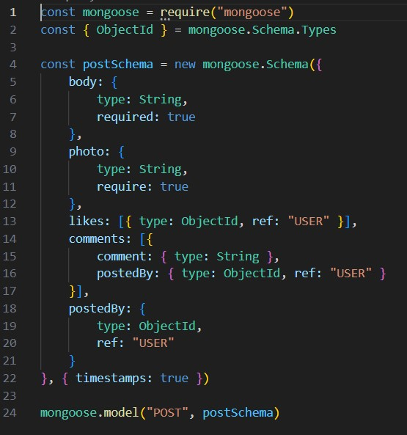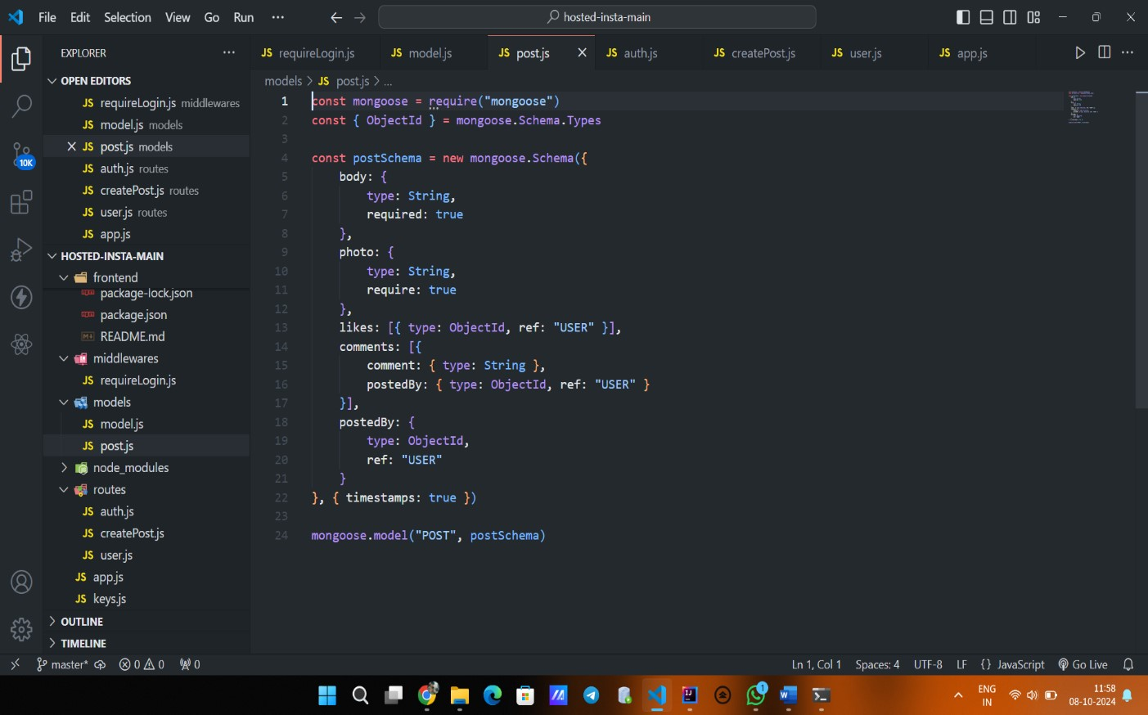

o

Authentication

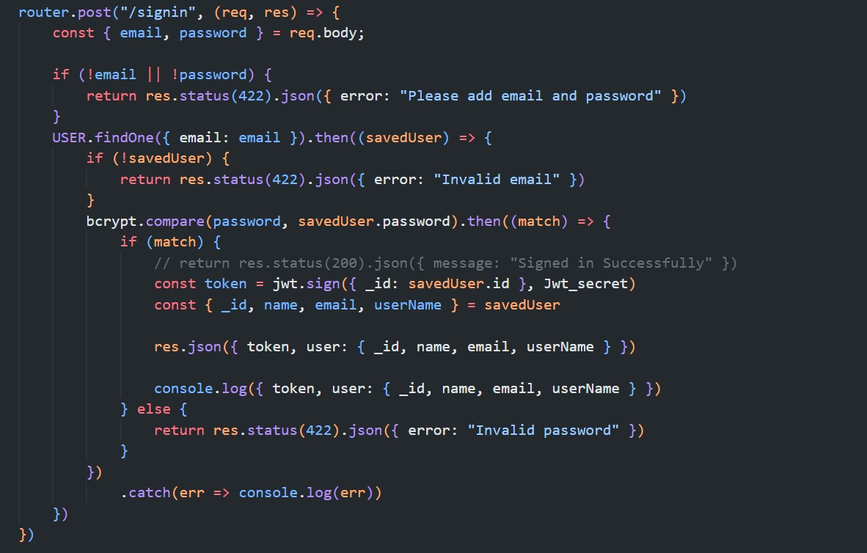

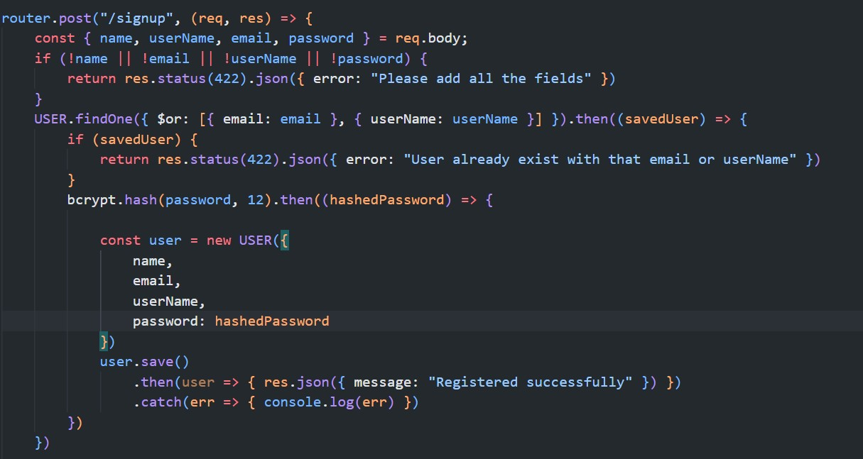

o App.js

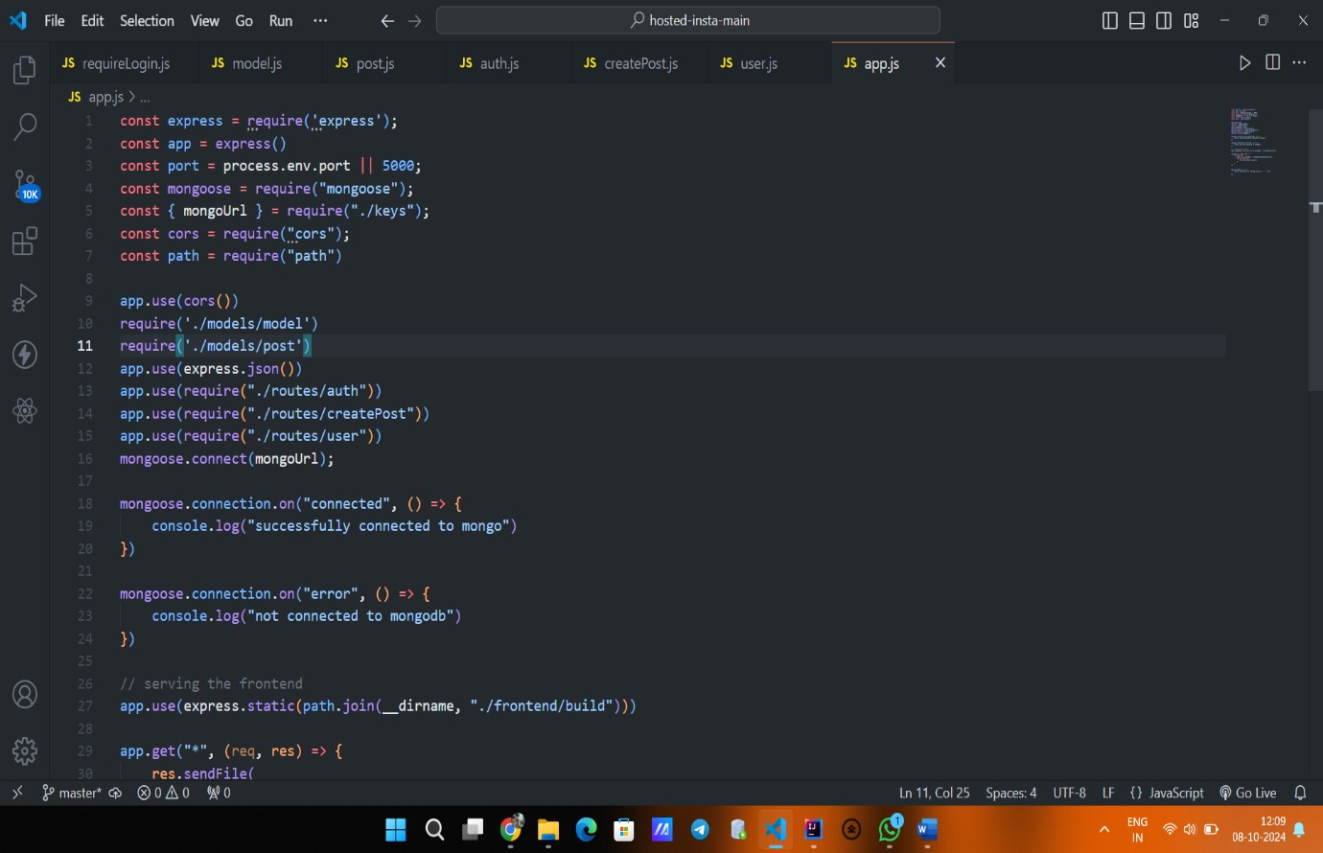

1. **System Testing**

System testing for *U-Share* ensures that the platform functions correctly and meets the specified requirements. The testing process includes:

* 1. **Unit Testing:** Individual components (frontend and backend) are tested separately to verify their functionality and performance. This helps identify bugs at an early stage.
  2. **Integration Testing:** Testing interactions between different modules (e.g., frontend communicating with the backend) to ensure they work seamlessly together**.**
  3. **Functional Testing:** The system is tested against functional requirements to confirm that all features, such as user registration, resource sharing, and coding challenges, work as intended**.**
  4. **Usability Testing:** Evaluating the user interface and overall user experience to ensure the platform is intuitive and easy to navigate**.**
  5. **Performance Testing:** Assessing system performance under varying loads to ensure it can handle multiple users and requests simultaneously without degradation.

1. **Limitations:**

Despite its benefits, *U-Share* has certain limitations:

* 1. **Technical Challenges:** Ensuring scalability and handling potential technical issues like bugs and downtime can be complex.
  2. **User Engagement:** Achieving consistent participation from students may be challenging, as the platform relies on user-generated content.
  3. **Privacy and Security Risks:** Protecting user data is crucial; risks include unauthorized access and potential data breaches.
  4. **Feature Limitations**: Current functionalities may not include advanced features like chatting, video conferencing, file encryption, or extensive customization options, which some users might require.

* 1. **Digital Divide:** Not all students may have reliable internet access or devices, which could limit participation.
  2. **Resource Quality Control:** Moderation is needed to ensure the accuracy and relevance of shared resources, preventing the spread of outdated information.
  3. **Dependency on Technology:** Over-reliance on the platform may reduce faceto-face interactions, impacting social learning.

By recognizing these limitations, *U-Share* can continuously improve and address challenges in its development and operation.

1. **Conclusion:**

*U-Share* serves as an innovative platform designed to enhance collaboration and resource sharing among university students. By providing a centralized repository for study materials, interactive workspaces, and a coding challenge arena, it fosters an environment conducive to learning and peer interaction. Despite its limitations, such as initial development costs and the need for user engagement, the platform addresses key challenges faced by students in accessing resources and collaborating effectively. With continuous improvement and user feedback, *U-Share* has the potential to evolve into a vital educational hub, empowering students to succeed academically and professionally. In summary, *U-Share* represents a significant step towards enhancing educational experiences through technology, fostering a strong sense of community, and preparing students for real-world challenges.

1. **Future Scope:**

*U-Share* aims to enhance its platform by incorporating AI-driven personalized learning paths and developing a mobile application for greater accessibility. Future developments include integrating learning analytics to track user progress, forming partnerships with educational institutions for wider resource sharing, and expanding its user base to include high school students and lifelong learners. Additionally, the introduction of gamification elements will boost user engagement, ensuring *U-Share* remains relevant and impactful in the evolving educational landscape.

1. **Refrences:**

* [https://react.dev](https://react.dev/)
* <https://expressjs.com/>
* <https://nodejs.org/docs/latest/api/>
* [https://w3schools.com](https://w3schools.com/)
* <https://www.youtube.com/>
* <https://developer.mozilla.org/en-US/>
* [https://github.com](https://github.com/)